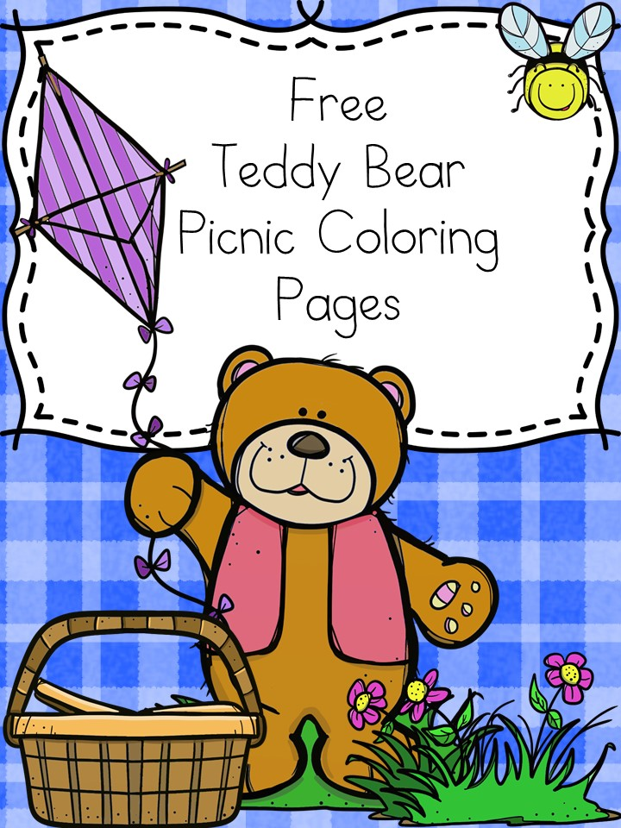



$22.99 per person

Includes Lunch, Power Card, activities & prizes!

Buy tickets now at:

<https://dnb.ticketbud.com/dnb_buffalo_teddy_bear_picnic>

\*offer valid 7/10/17. Cannot be combined with any other offer. See store for details.

Send Invites Now

Check In Guests



Join us for a

Teddy Bear Picnic!

Dave and Buster’s

Walden Galleria

July 10th 11am-2pm