

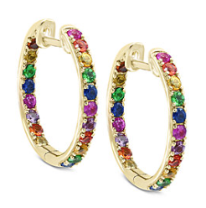

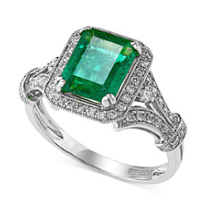

**One Day Only**

Designer Jewelry Event

Featuring

EFFY

February 27, 2019

10am-6pm

You are invited to a rare opportunity showcasing Effy Fine Jewelry. Effy is designed and hand-crafted in New York City using only the best quality gemstones, diamonds, and gold.

Only at

Macy’s Walden Galleria

716-684-6267

Extension 568

4 Walden Galleria Dr

Cheektowaga, NY 14225

Contact a Fine Jewelry consultant to book your appointment for this special one day only event!

Teal Box Specials:

