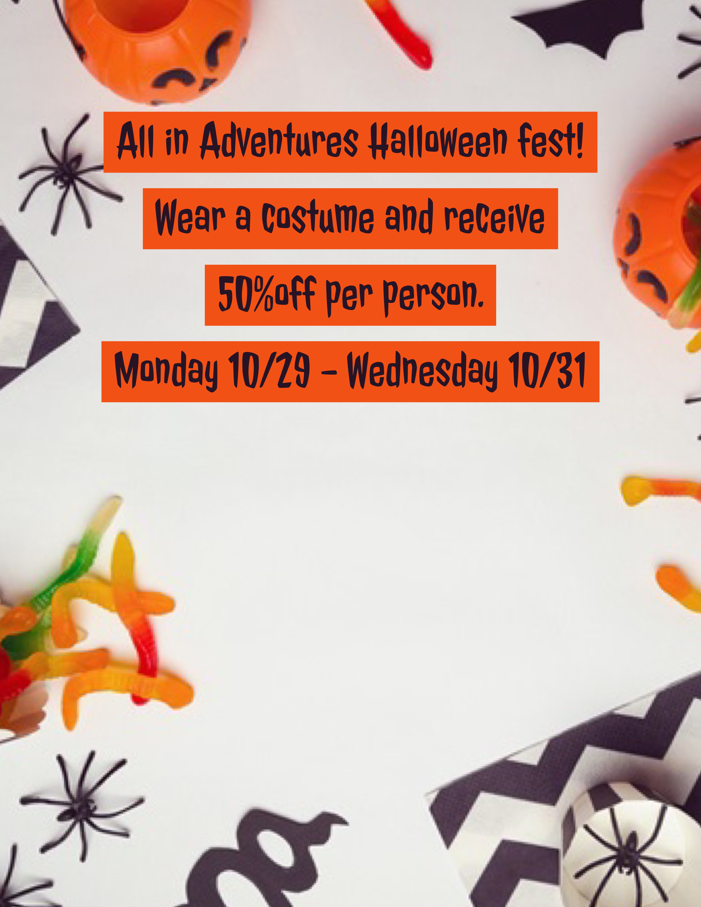

Receive 10% off your birthday party with the purchase of a game and food package! Stop by or call your local store for details!

Receive 10% off your birthday party with the purchase of a game and food package! Stop by or call your local store for details!

Discount not be combined with any other offers

Quantities are limited

**9090 Destiny USA Dr**

**Syracuse NY 13204**

**Email us at store107@allinadventures.com**

**Phone:315-423-5140**

**Stop in for a free picture and candy from us at**

**Escape The Mystery Room!**

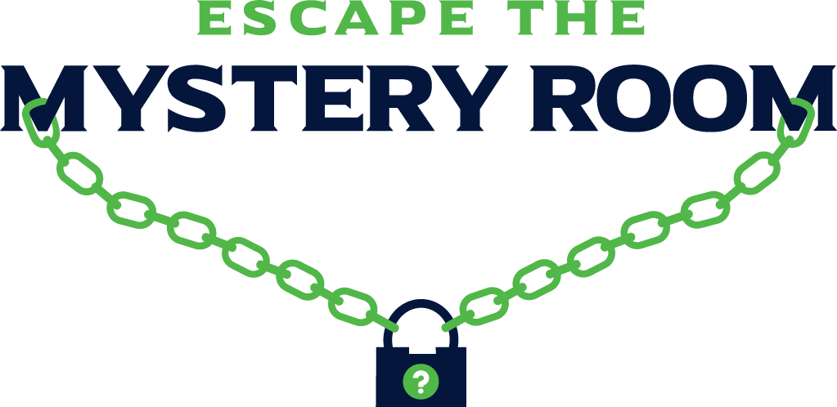

Escape From Alcatraz : Black Op’s: Treasure Island : Houdini’s Magic Cell : Zombie Apocalypse : Sherlock’s Library : Special Agent : Superhero’s Adventure : Hollywood Premier