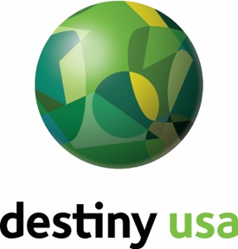

PRESS RELEASE

**Media Contact:**

Nikita Jankowski, (315) 706-4443, njankowski@destinyusa.com

**BEEF JERKY OUTLET COMING SOON!**

Destiny USA prepares to beef up the tenant roster

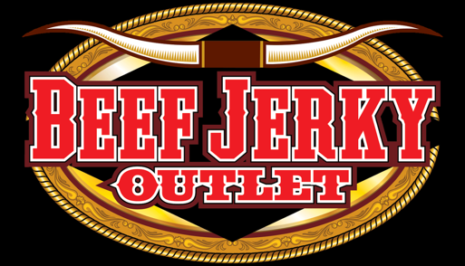**Syracuse, NY (February 13, 2019)** – “Where’s the beef?” That’s a question that will soon be answered as the nation’s leading jerky retailer, Beef Jerky Outlet, prepares for its debut at Destiny USA.

The Beef Jerky Outlet is aiming to open on the second level of Destiny USA’s expansion, next to Finger Lakes Coffee Roasters by mid-March, 2019.

“I’m excited to offer this unique product to Destiny USA,” said owner John Schemm. “What’s unique about what we offer is that it’s not your regular beef jerky – it’s quality, has great flavor and variety.”

The nationally franchised outlet features over 100 varieties and sizes of beef jerky, ranging from mild to wild, alligator jerky and even salmon jerky. The brand is also known to carry gourmet popcorn, sauces, seasonings, marinades and much more.

“Beef Jerky Outlet has two plants that produce the jerky – in Michigan and Tennessee. Our customers will notice a distinct difference in the taste of the jerky based on where it’s from. Jerky from Michigan is more tender. Jerky from Tennessee has a chewy texture.”

There are more than 100 Beef Jerky Outlet locations owned and operated throughout the nation.

# # #

***About Destiny USA***

*Destiny USA is New York’s largest shopping, dining, outlet and entertainment destination and the sixth largest shopping center in the U.S. Centrally located in Syracuse, Destiny USA is visited by 26 million guests annually and consistently draws from a 4-hour drive and attracts tourists from all 50 states, Canada and worldwide. An unparalleled mix of shopping, dining, outlet and entertainment—all under one roof—combined with its new, onsite Embassy Suites by Hilton hotel cement Destiny USA’s reputation as a premier tourist destination. Plan your next visit to Destiny USA, Trip Advisor’s #1 travel destination in Central New York, today at*[*www.destinyusa.com*](http://www.destinyusa.com/)*.*

***About Pyramid Management Group, LLC***

*Pyramid Management Group, owner of Destiny USA, is one of the largest, most innovative, privately-held shopping center developers in North America. Headquartered in Syracuse, New York, Pyramid's portfolio of retail-based, tourist, and entertainment destinations dominate the northeast, with 16 properties located throughout New York, Massachusetts and Virginia. For over 40 years, Pyramid has led the industry by combining the best elements of traditional retail with world-class dining and entertainment, all under one roof. For more information, visit* [*www.pyramidmg.com*](http://www.pyramidmg.com)*.*