**HIRING EVENT**

**September 22nd**

**12-6p**

**Join the Macy’s team today &**

**earn more than just a paycheck!**

**Scan this QR code!**

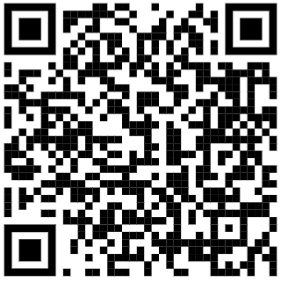

**macysJOBS.com**

**-Fully Funded Education Program** that covers 100% of tuition, books, and fees.

**-Flexible Time Off:** Take an extra day off for a holiday that’s most important to you!